Langchain Runnables - Part 2
https://www.youtube.com/watch?v=47nc0n-e4_w&list=PLKnIA16_RmvaTbihpo4MtzVm4XOQa0ER0&index=11
https://github.com/campusx-official/langchain-runnables
00:00 – Intro
00:47 – Recap
04:40 - Runnable Categories
09:30 – RunnableSequence
15:00 - Runnable Parallel
21:50 – RunnablePassthrough
30:03 – RunnableLambda
39:55 – RunnableBranch
50:07 – LCEL
LangChain Runnables – Part 2 Documentation

1. Introduction
This video continues the LangChain playlist with a deeper focus on Runnables.
In the previous video, runnables were introduced, but not all aspects could be covered. This second part focuses on:
- Runnable primitives
- How to build complex chains using them
- An introduction to LangChain Expression Language (LCEL)
Once you understand these concepts properly, you will be able to build any type of chain easily in LangChain.

2. Recap of Previous Video
Before moving forward, let’s briefly review what was covered earlier.
2.1 LangChain Components
LangChain initially provided many core components such as:
- Prompt Templates – for designing prompts
- LLMs – for interacting with language models
- Output Parsers – for processing LLM responses
- Retrievers – for fetching relevant documents
These components allowed engineers to plug and play to build LLM applications.

2.2 The Problem: Lack of Standardization
Each component had different method names:
Component | Method Used
Prompt Template | format()
LLM | predict()
Parser | parse()
Retriever | get_relevant_documents()
Because of this:
- Components were hard to connect
- Building flexible workflows was difficult

2.3 The Solution: Runnables
LangChain standardized all components by:
- Creating an abstract Runnable interface
- Forcing every component to implement common methods like:
  - invoke()
  - batch()
  - stream()
This made all components compatible and easily connectable.
Now:
- Output of one runnable automatically becomes input of the next
- Complex workflows can be built easily

3. Runnable Categories
LangChain runnables are divided into two main types:
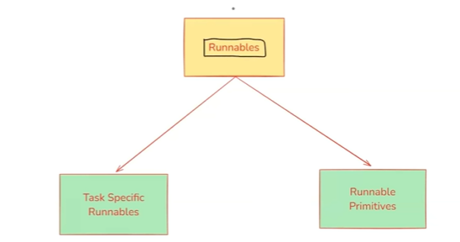
3.1 Task-Specific Runnables
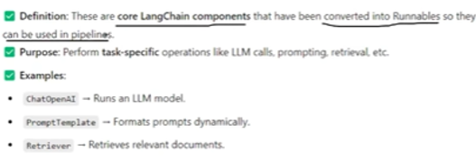
These are the original LangChain components converted into runnables.
Examples:
- PromptTemplate
- ChatOpenAI (LLM)
- Retrievers
- Output Parsers
Each has a specific purpose:
Runnable | Purpose
Prompt Template | Design prompts
LLM | Generate responses
Parser | Format output
Retriever | Fetch documents
They are now standardized and can be connected in pipelines.

3.2 Runnable Primitives
Runnable primitives are special runnables used to connect and orchestrate task-specific runnables.
✅ Definition: These are fundamental building blocks for structuring execution logic in AI workflows.
✅ Purpose: They help orchestrate execution by defining how different Runnables interact
(sequentially, in parallel, conditionally, etc.).

✅ Examples:
- RunnableSequence → Runs steps in order (| operator).
- RunnableParallel → Runs multiple steps simultaneously.
- RunnableMap → Maps the same input across multiple functions.
- RunnableBranch → Implements conditional execution (if-else logic).
- RunnableLambda → Wraps custom Python functions into Runnables.
- RunnablePassthrough → Just forwards input as output (acts as a placeholder).
Commonly used are:
- Sequential execution
- Parallel execution
- Conditional logic
Think of them as workflow builders.

4. RunnableSequence
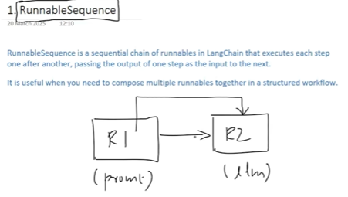
4.1 Purpose
RunnableSequence connects multiple runnables one after another (sequentially).
Output flow:
R1 → R2 → R3 → ... → Final Output
The output of each runnable becomes the input of the next.

4.2 Why It Exists
In the previous video, a custom “RunnableConnector” was created manually to do this.
LangChain now provides this built-in feature as:
👉 RunnableSequence
So you no longer need to write custom connector code.

4.3 Simple Example: Joke Generator
Step 1: Create components
- Prompt Template → “Write a joke about {topic}”
- LLM model (ChatOpenAI)
- String Output Parser
Step 2: Create sequence
Prompt → Model → Parser
Using RunnableSequence.
Step 3: Invoke
Input:
topic = "AI"
Output:
- A joke about AI in string format

4.4 Extended Sequential Chain: Joke + Explanation
A longer sequence can be built:
- Prompt 1 → Generate joke
- Model → LLM response
- Parser → Joke text
- Prompt 2 → “Explain the following joke {text}”
- Model → Explanation
- Parser → Final output
Final output will be:
👉 Explanation of the joke
This demonstrates how easily multi-step workflows can be built.
runnable_sequence.py
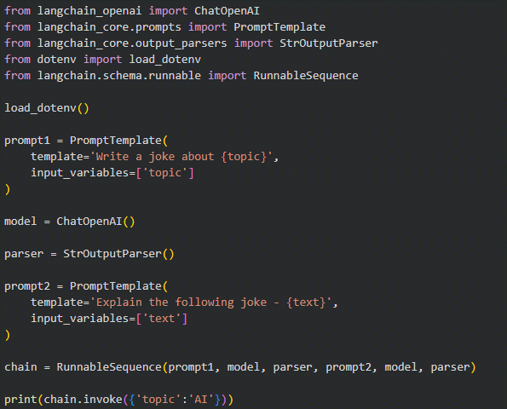

5. RunnableParallel
5.1 Purpose
RunnableParallel executes multiple runnables at the same time.
Key characteristics:
- All runnables receive the same input
- They run independently in parallel
- Output is returned as a dictionary

5.2 Concept Example
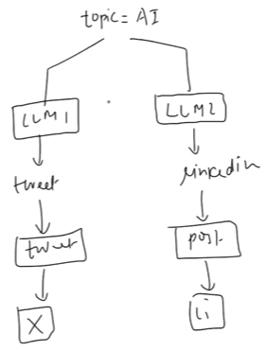
Input:
topic = "AI"
Two parallel chains:
- Chain 1 → Generate a tweet about AI
- Chain 2 → Generate a LinkedIn post about AI
Both execute at the same time.
Final output:
{
"tweet": "AI is transforming the world...",
"linkedin": "Artificial Intelligence is reshaping industries..."
}

5.3 Implementation Flow
runnable_parallel.py
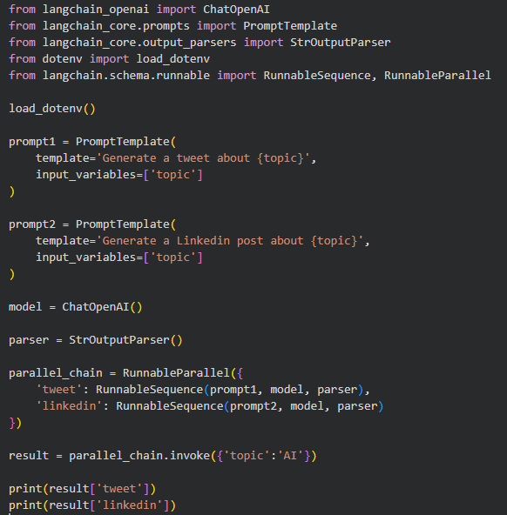
Step 1: Create two prompts
- Prompt 1 → Generate tweet
- Prompt 2 → Generate LinkedIn post
Step 2: Create model and parser
- One LLM instance
- One StringOutputParser
Step 3: Build parallel chain
Each branch uses:
Prompt → Model → Parser
Wrapped inside RunnableParallel as dictionary entries:
{
"tweet": RunnableSequence(...),
"linkedin": RunnableSequence(...)
}

5.4 Execution
When invoking:
parallel_chain.invoke({"topic": "AI"})
Both sequences run in parallel and return a dictionary of results.
You can then extract:
- result["tweet"]
- result["linkedin"]

6. Summary So Far
Concept | Role
Task-Specific Runnables | Core components like LLM, prompt, parser
Runnable Primitives | Workflow builders/Components
RunnableSequence | Connects runnables sequentially
RunnableParallel | Runs multiple chains simultaneously

7. RunnablePassthrough
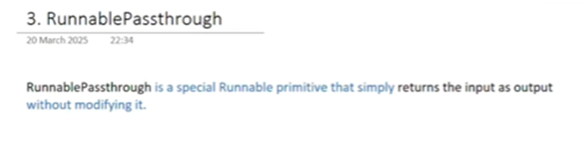
7.1 Overview
RunnablePassthrough is a special runnable primitive that returns the input exactly as it is.
It does not:
- Modify data
- Process input
- Apply transformations
It simply forwards the input to the output.

7.2 Basic Behavior
Examples:
Input | Output
2 | 2
{"name": "Nitish"} | {"name": "Nitish"}
This confirms that the runnable behaves as a pure pass-through component.

7.3 Why RunnablePassthrough Is Needed
Although it looks simple, it becomes useful when:
- You want to keep intermediate results
- While also processing them in other branches
Especially helpful in parallel chains.

7.4 Problem in Sequential Chains
Previously, a sequential workflow was built:
- User provides a topic
- Joke is generated
- Joke explanation is generated
Final output only showed:
→ Explanation
The original joke was lost.

7.5 Requirement
We want both:
- Joke
- Explanation
to appear in the final output.

7.6 Workflow Using RunnablePassthrough
Step 1: Joke Generator Chain
Prompt1 → LLM → Parser
Output: Joke

Step 2: Parallel Chain
Two branches:
Branch 1: Explanation Chain
Prompt2 → LLM → Parser
Branch 2: Passthrough
RunnablePassthrough

Step 3: Combined Flow
Joke Chain
↓
RunnableParallel
├── joke → RunnablePassthrough
└── explanation → RunnableSequence

7.7 Final Output Structure
{
"joke": "Generated joke text",
"explanation": "Explanation text"
}

7.8 Key Advantages
- Preserves original output
- Enables parallel processing
- Useful for logging and debugging
Working of RunnablePassthrough:
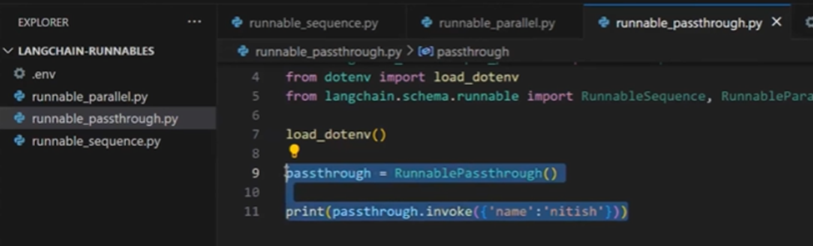
runnable_passthrough.py
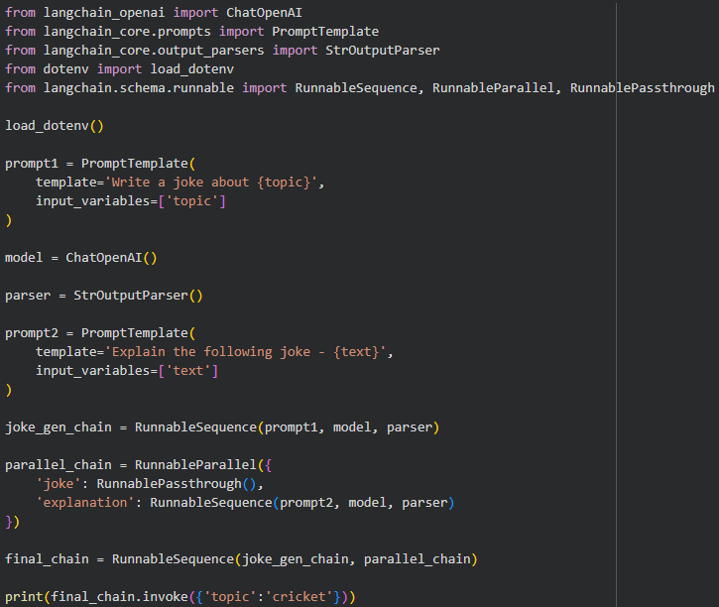

8. RunnableLambda

8.1 Overview
RunnableLambda allows you to convert any Python function into a runnable component.
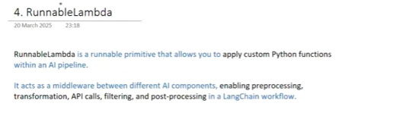
Once converted:
- It follows runnable interface
- Can be connected in chains
- Becomes part of LangChain workflows

8.2 Motivation
Some tasks are better handled by Python rather than LLMs, such as:
- Text cleaning
- Counting words
- Data transformation
- Preprocessing
RunnableLambda integrates these tasks into pipelines.

8.3 Preprocessing Example
Customer reviews may contain:
- HTML tags
- Emojis
- Special characters
A preprocessing Python function can clean this data and then pass it to LLM.
Flow:
Raw Text → RunnableLambda (cleaning) → LLM → Parser

8.4 Simple Word Count Runnable
Python Function:
def word_counter(text):
return len(text.split())
Convert to Runnable:
RunnableLambda(word_counter)

8.5 Invocation Example
runnable.invoke("This is a sample sentence")
Output:
5

8.6 Joke + Word Count Workflow
Step 1: Generate joke (sequential)
Prompt → LLM → Parser

Step 2: Parallel processing
- RunnablePassthrough → keeps joke
- RunnableLambda → counts words

Step 3: Final structure
Joke Chain → RunnableParallel
├── joke → RunnablePassthrough
└── word_count → RunnableLambda

8.7 Final Output
{
"joke": "Joke text here",
"word_count": 12
}

8.8 Lambda Shortcut
Instead of full function:
RunnableLambda(lambda x: len(x.split()))

8.9 Key Benefits
- Adds custom logic into chains
- Reduces dependency on LLM
- Improves efficiency
- Makes workflows flexible
Simple example of RunnableLambda
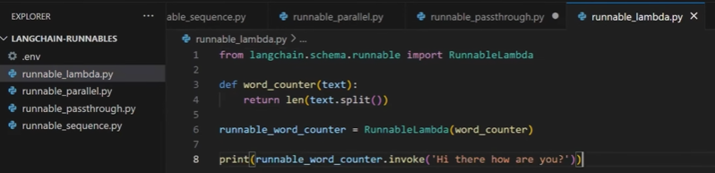
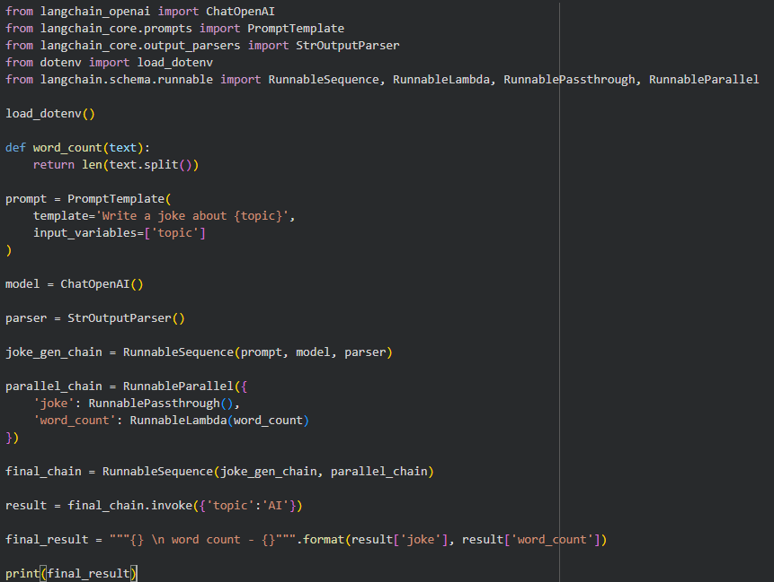

9. RunnableBranch
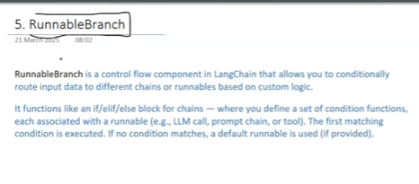
9.1 Overview
RunnableBranch is used to create conditional workflows in LangChain.
It works like an if–else statement in programming.
Based on a condition, different runnable chains are executed.

9.2 When to Use RunnableBranch
RunnableBranch is useful when:
- The next step depends on some condition
- Different logic should run for different inputs
You can think of it as:
Decision-making inside LangChain pipelines.

9.3 Real-World Example: Email Processing System
Imagine a system receiving customer emails:
Possible types:
- Complaint
- Refund request
- General query
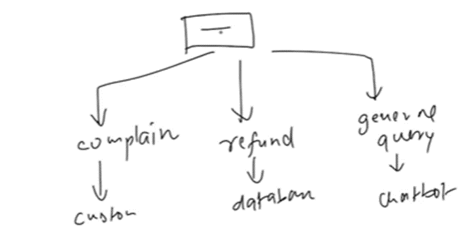
Desired behavior:
Email Type | Action
Complaint | Forward to customer support
Refund | Trigger database process
General query | Chatbot replies

9.4 How This Works with RunnableBranch
Step 1: Analyze email with LLM
Prompt asks LLM to categorize email into:
- Complaint
- Refund
- General query

Step 2: RunnableBranch decides flow
Three branches:
- Complaint handling chain
- Refund handling chain
- General query handling chain
Only one branch executes based on LLM output.
The above use case can also be converted into a project. For example, if it is a complaint, the system can automatically send an email to the customer support team by accessing an email tool.

9.5 Key Concept
RunnableBranch allows:
- Conditional execution
- Dynamic workflows
Whenever future steps depend on a condition, RunnableBranch is the solution.

9.6 Practical Coding Example: Report Generation & Summarization
Goal:
- Generate a detailed report on a topic
- If report > 500 words → summarize it
- Else → print as-is

9.7 Step-by-Step Flow
Step 1: Report Generation Chain
Prompt1 → LLM → StringOutputParser
Generates detailed report.

Step 2: Create Summary Prompt
Used only when report is long:
Summarize the following text:
{text}

Step 3: RunnableBranch Conditions
Structure:
RunnableBranch accepts:
- Tuples (condition, runnable)
- Last item = default (else case)
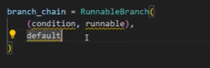

9.8 Word Count Condition
Condition logic:
- Count words in report
- If > 500 → trigger summarization chain
- Else → pass output as-is
Lambda used:
lambda x: len(x.split()) > 500
Where x is the report text from parser.

9.9 Branch Behavior
Condition | Runnable Executed
Words > 500 | Summarization chain
Words ≤ 500 | RunnablePassthrough

9.10 Final Chain Structure
Report Generation Chain → RunnableBranch

9.11 Output Behavior
Case 1: Report < limit
→ Full report printed
Case 2: Report > limit
→ Summarized version printed

9.12 Key Benefits of RunnableBranch
- Implements conditional logic
- Makes workflows intelligent
- Avoids unnecessary LLM calls
- Supports dynamic decisions
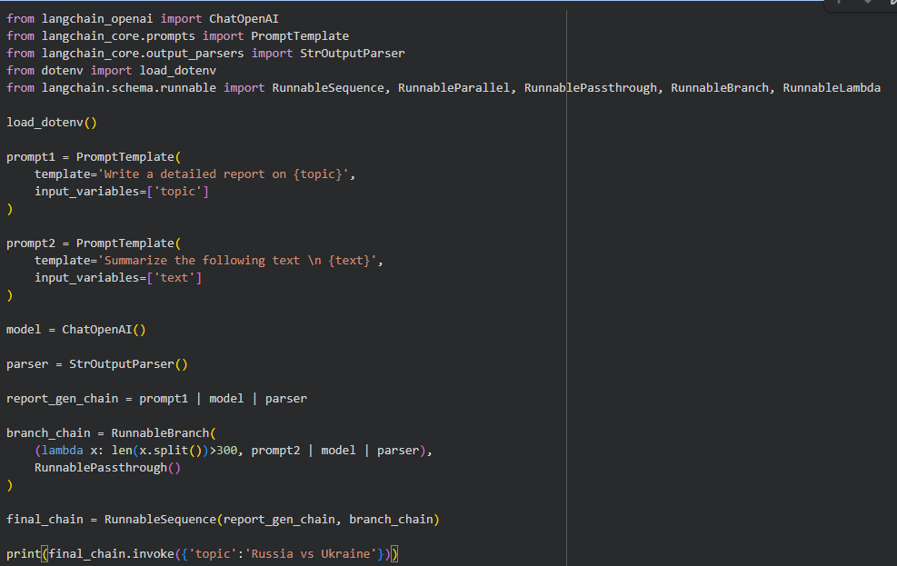

10. LCEL (LangChain Expression Language)
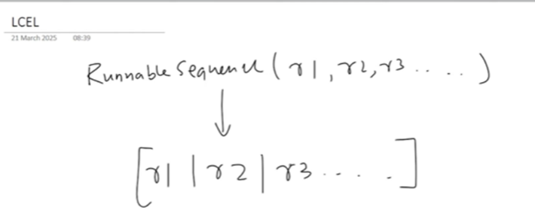

10.1 What Is LCEL?
LCEL stands for:
LangChain Expression Language
It is a declarative syntax for building runnable chains more simply.

10.2 Why LCEL Was Introduced
Observation:
RunnableSequence is used everywhere:
- Sequential chains
- Inside parallel chains
- Inside branches
- In most workflows
But syntax was verbose:
RunnableSequence([R1, R2, R3])

10.3 LCEL Simplified Syntax
Instead of:
RunnableSequence([R1, R2, R3])
You can now write:
R1 | R2 | R3
This uses the pipe operator ( | )

10.4 Benefits of LCEL
- Cleaner code
- More readable
- Declarative style
- Easier to compose chains

10.5 Example Comparison
Old style:
RunnableSequence(prompt, model, parser)
LCEL style:
prompt | model | parser
Both do the same thing.

10.6 Current Scope of LCEL
Right now:
- LCEL supports sequential chains only
In future:
- Parallel chains may get syntax like:
R1 & R2
- Branches may get declarative expressions too
(Conceptual future improvement)

10.7 Using LCEL with Previous Examples
The same RunnableBranch example can be rewritten using:
report_chain | branch_chain
Instead of creating RunnableSequence explicitly.

10.8 Output Remains the Same
LCEL is just syntax sugar.
Internally:
- Same execution
- Same results
Only code becomes simpler.

10.9 Why LCEL Is Important
LCEL is the future direction of LangChain.
Going forward:
- Most workflows will be written using pipe syntax
- RunnableSequence will be used less directly

11. Final Summary of Runnables Part 2
Runnables Covered:
Runnable | Purpose
RunnableSequence | Sequential execution
RunnableParallel | Parallel execution
RunnablePassthrough | Return input unchanged
RunnableLambda | Custom Python logic
RunnableBranch | Conditional workflows
LCEL | Declarative syntax for chains
Key Takeaways
- Runnables standardize LangChain components
- Complex workflows can be built easily
- LCEL simplifies sequential chaining
- Conditional and parallel logic are fully supported

